BRIEF FOR
CONSERVATION WORKS AT ASHCOMBE GARDENS, SIMONSBATH,
EXMOOR NATIONAL PARK.

Written quotes are invited for two separate pieces of work. Separate quotes should be submitted for either or both of the items below. For clarity during the assessment phase, please present these as entirely separate items, labelled: ‘Ashcombe repairs Item 1’ and ‘Ashcombe repairs Item 2’.
Quotes to be sent by email or by post to: Rob Wilson-North, Head of Access, Engagement & Estates, Exmoor National Park Authority, Exmoor House, Dulverton, Somerset, TA22 9HL. For any queries or to arrange a visit to assess and discuss the proposed works please email rwilson-north@exmoor-nationalpark.gov.uk or phone 07812 945152. Please submit quotations by Wednesday 12th March, 2025.
The site is in Ashcombe, Simonsbath, Exmoor National Park, TA24 7SH. A public car park in Ashcombe is the site access point. The site and the car park are owned by Exmoor National Park Authority.

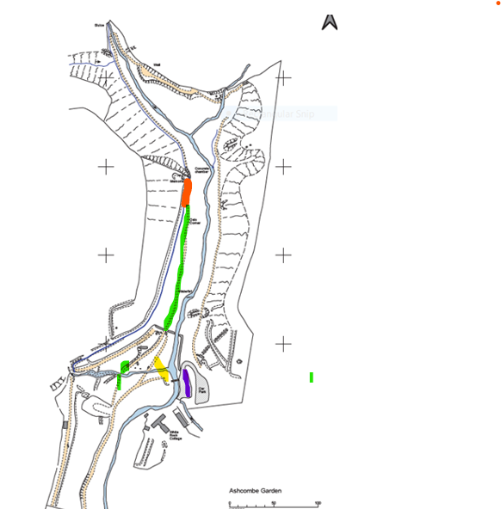
Key: purple = site parking; red = dry stone wall repairs (item 1); green = path repairs (item 2); yellow = temporary path to be entirely removed, and some to be used as per the brief
ASHCOMBE REPAIRS ITEM ONE
BRIEF FOR DRYSTONE WALL REPAIRS IN ASHCOMBE
To repair/rebuild dry stone walling (red on plan) which forms part of a leat retaining wall in Ashcombe. (Note - access to the site is up a narrow pedestrian path for 200 metres – there is no vehicle access, except for a narrow track barrow).
1.
Allow for 15 metres of rebuilding of the wall to match the existing. The wall to be capped with pitched stone and earth infill to match existing.
2.
Allow to push back slumped drystone walling – allow for 4 metres of this. If it cannot be pushed back, allow for taking down and rebuilding to match existing (as per 1 above).
Please submit a quote providing a detailed breakdown of costs. (Either including or excluding you supplying a suitable stone to match the existing on site).
All works are to be carried out sensitively using local stone and the minimum of ground disturbance. This is due to the historical importance of the gardens which were laid out around 1820. The purpose of the work is to enable access around the historic gardens.
The site to be left clean and tidy with excess materials removed and any ground damage made good. Access to the site is from a public car park and you will need to set out how you intend to use that space and how you will minimise inconvenience and risk to the users of the car park.

ASHCOMBE REPAIRS ITEM TWO
(Item 2 will be carried out separately to item 1 and cannot be done until Item 1 has been completed)
BRIEF FOR PATH REPAIRS IN ASHCOMBE
This item comprises path repairs on the west path in Ashcombe running from the meadow (picnic area) adjacent to the car park as far as the ‘pulpit’ half way up the western side of Ashcombe. The objectives are to repair the path through i. carefully removing and setting aside soil overburden on the path where needed, ii. Repairing the simple pitched stone edging along the path where needed, iii. Infilling the hollows in the path and top dressing them with fine local gravel, iv. Works to the path either side of the newly installed wooden bridge in the meadow (‘picnic area’) so that the path rises gently to meet the bridge to enable step-free access over it, v. the careful removal and disposal of the temporary path within the marsh area.
All works are to be carried out sensitively using local stone and the minimum of ground disturbance. This is due to the historical importance of the gardens which was laid out around 1820. The purpose of the work is to enable access around the historic garden.
Working from north to south:
- From the pulpit wall scrape back/infill path, as needed, to provide a safe, graded surface
- At Oslo Corner (see plan), allow to install two stone cross drains (detail to be agreed)
- Repair simple pitched stone edging – allow 5 metres
- Infill hollowing adjacent to the waterfall using stone for temporary path in marsh area.
- Allow to raise path level for around 10 metres using fine stone, in order to assist drainage
- Allow to install three stone cross drains
- Allow 10 metres of stone edging
- At old path junction infill the hollow with stone from the marsh area path and allow 5 metres of simple pitched stone edging here.
Around the new wooden bridge:
- Allow for 2 metres of simple pitched stone edging and path infill on north side of wooden bridge using stone from marsh temporary path; ensure clean stone against the bridge end; dress path with local fine stone gravel
- South of wooden bridge, carefully cut path level for up to 6 metres to meet bridge; allow for some infilling using stone from marsh temporary path; ensure clean stone against wooden bridge end; and for simple pitched stone edging; top dress with fine local stone.

The site to be left clean and tidy with excess materials removed and any ground damage made good.

ASSESSMENT OF SUBMISSIONS
6. Selection process
Selection will be based on the following criteria (which are not listed in order of importance). Each criterion is scored out of 1-5, the weighting that will be applied to each criteria is shown in brackets:

Criteria | Weighting
Understanding of the brief and proposed approach to delivering the work | (x3)
Capacity and resilience: The ability of you/your organisation to deliver the work requested within the timeframe | (x1)
Capability: Skills and knowledge of the personnel that will be undertaking the tasks requested | (x2)
Experience: Please give details of your company’s / organisation’s involvement in similar projects | (x4)
Fees: A breakdown of the costs you would propose to charge for undertaking the work requested | (x3)

The following definitions will be used in scoring submissions:

Definition | Score
Brief not answered adequately. Does not meet minimum requirements or provide a viable solution | 1
Only partially satisfies requirement, major deficiencies apparent. | 2
Response meets acceptable criteria but is not comprehensive. Is sufficient response but more detailed proposals would score higher. | 3
Response satisfies the brief and add a good degree of value and information. | 4
Proposals very comprehensive and/or innovative so as to exceed expectations | 5

Exmoor National Park Authority:
• Shall not be bound to accept the lowest or any quotation
• May, at its sole discretion, accept the whole or part of any quotation; and
• Will require the preferred supplier to enter into a contract based on the terms of this invitation to quote, the written quotation and the Authority’s standard conditions of contract

7. Disqualifications
The Authority will not consider any quote in respect of which the Respondent or any person acting on the Respondent’s behalf, or with the consent, approval or knowledge of the Respondent is reasonably believed to have:
• directly or indirectly canvassed or attempted to canvass any Officer or Member of the Authority
• obtained or attempted to obtain information concerning the Invitation to Quote or award of the Contract or any other quotes from any Officer or Member of the Authority or any other person who supplies services to the Authority;
• fixed or adjusted or attempted to fix or adjust the prices shown in the Pricing Schedule by or in accordance with any agreement or arrangement with any other person;
• communicated or attempted to communicate to any person other than the Authority the amount or approximate amount of the prices shown in the Pricing Schedule, except where such disclosure is made in confidence in order to obtain quotations necessary for the preparation of the quote or for the purposes of insurance or financing;
• entered or attempted to enter into any agreement with any other person to the effect that such other person shall refrain from submitting a quote, or shall limit or restrict the prices to be shown or referred to in another quote;
• paid, offered or agreed to pay to any person any sum of money, inducement or valuable consideration, directly or indirectly, for doing or having done or causing or having caused to be done, or forbearing to do in relation to a quote;
• committed an offence under the Prevention of Corruption Acts 1889 to 1916 or given any fee or reward the receipt of which is an offence under Section 117(2) of the Local Government Act 1972 or the Bribery Act 2011.

8. Freedom of Information
Information relating to any contract or procurement exercise to which the Authority is a party, including information about price and performance, is covered by the Freedom of Information Act 2000 (the Act). The Authority is under a legal obligation to disclose such information if requested unless an exemption under the Act applies.
Any person submitting a Quotation or entering into a contract with the Authority should, as part of the contract process, inform the Authority of any information which it regards as being confidential and/or eligible for a claim for exemption from disclosure by the Authority under the Act. The final decision as to what information can be disclosed rests with the Authority.

